**Exploring Weather Trends**

The data I analysed can be found in the following link:

https://docs.google.com/spreadsheets/d/1F10vS8eJpefSmG6fVnlcKZACsoF5aIKL_IE9igGw9rs/edit?usp=sharing

**Summary:**

In this project, I will analyse local and global temperature data and compare the temperature trends from the city of **Berlin, Germany** to overall global temperature trends.

**Goal:**

Creating a visualisation and preparing a write up containing the similarities and differences between global temperature trends and temperature trends in Berlin, Germany.

This can be done by analysing the moving average of temperature globally and locally in Berlin.

**Steps:**

1. **Extraction of data:**

SELECT city.year,city.city,city.country,city.avg_temp as city_avg_temp, global.avg_temp as global_avg_temp

FROM city_data as city

INNER JOIN global_data as global

on city.year = global.year

WHERE city.country = 'Germany'

AND city.city = 'Berlin'

AND city.avg_temp IS NOT NULL;

* I used the above query to retrieve the data from the database.
* It is a single SQL query to retrieve both city and global temp joined by the year. To separate the missing average values in the global data, I used inner join, separating the records belonging to those years entirely.
* Results were downloaded as results.csv file

1. **Calculating the moving average from the CSV:**

* I have done the analysis using Microsoft Excel.
* Calculated the moving average of intervals 5, 10, 15 years to see which is a better fit to analyse the temperature trends.
* Snapshot below shows the formula and the average values in the datasheet.
* The moving average was calculated using the formula from the Excel sheet.

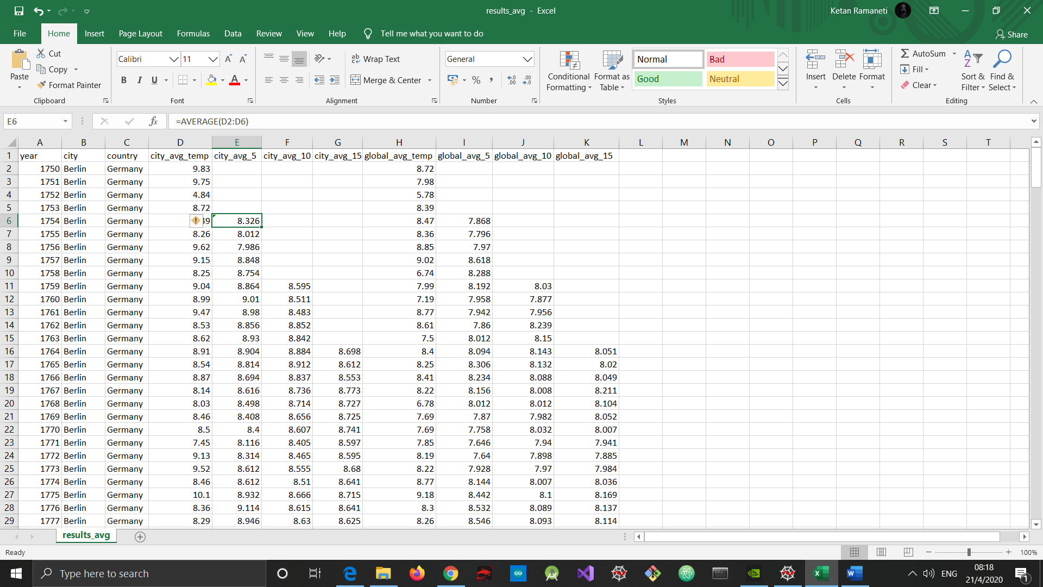

1. **Creating the line charts for comparison between Berlin’s temperature with global temperature.**

* After observing the temperature trend comparison between the city and global temperature, after analysing the 15 year Moving average is better to analyse the data.
* I chose the 15 year Moving average cart because the noise is relatively less compared to that of 5 year and 10 year moving average.

1. **Observations:**

* From the chart of 15-year average comparison, it can be observed that Berlin is hotter than other countries on average.
* The temperature of Berlin over the years is higher than the average global temperature.
* The difference between both the temperatures is almost similar over the years. The average difference is calculated to be 0.56 degree Celsius.
* There is a period between around 1823 to 1845 where the temperature difference observed is more than that of average difference. During this period the global temperature decreased and in case of Berlin, the temperatures decreased too but insignificant when compared to that of decrease in global temperature.
* From 1880 onwards, the global temperature is increasing quite smoothly. For Berlin too the temperature has been increasing over the years but has more spikes than the global temperature.
* It can be clearly observed that the world is getting hotter as the years proceed. Both temperature averages have been increasing over years gradually.
* This increase in temperature over the years is a similarity between the global and city average temperature.
* This relationship amongst the average temperatures can be verified by their correlation coefficient value of 0.897386.